**Spatial Differences in Fine Particulate Matter Exposure across the Salt Lake School District: Case Study Dust Storm of December 20th, 2017**

**Introduction**: The Utah Recess Guidance is a set of recommendations developed to protect school children from exposure to poor outdoor air quality, particularly during winter time inversion events when fine particulate matter (PM2.5) is often elevated. The pollutant concentration is read at 8 AM from the nearest Utah Division of Air Quality (UDAQ) sensor and used as a guideline for whether or not children should be allowed to play outside during recess. There are several problems with this approach. UDAQ air quality data is updated hourly so there is an hour delay in resolving air quality levels that can change quickly. Stationary monitoring is sparse (typically between one to three per county) and therefore cannot resolve spatial variability in outdoor air quality across urban centers. Here we investigate a new method for estimating PM2.5 concentrations at 40 schools in the Salt Lake School District (SLSD) using all available stationary and mobile observation platforms during a dust event on December 20th, 2017 (Figure 1).

**Methods**: We modeled 5-minute PM2.5 exposure at 40 SLSD schools using an inverse-distance weighted approach with data from UDAQ and University of Utah stationary and TRAX-mounted sensors. Hourly Hawthorne UDAQ values used for recess guidance were compared with our modeled exposure at each school.

**Results**: This short-lived dust event caused PM2.5 to exceed unhealthy levels between 10 AM and 1 PM (Figure 2), when school children would typically be let outside for recess or lunch. Although the SLSD spans only ~7 miles East-West and ~6 miles North-South, the modeled exposure varied greatly with differences up to 120 µg/m3. Since PM2.5 at the Hawthorne UDAQ site was <20 µg/m3 before 9 AM and ~50 µg/m3 at 10 AM, the recess guidelines would have been unrestricted in the morning and only restricted for sensitive or compromised children at 10 AM, allowing children to have been exposed to dangerously high PM2.5 levels during recess that day.

**Conclusions**: Modeled PM2.5 exposure varied by an order of magnitude across the SLCD during the dust event of December 20th, 2017. Our new exposure modeling method using observations from an extensive air quality monitoring network could be used to provide improved recess guidance for SLCD schools to protect children’s health. Although dust events occur only 1-5 times per year, they are predicted to become more common due to a drier and warmer climate and an increase in exposed playa surfaces on the shrinking Great Salt Lake, so improving recess guidance capabilities is important for protecting children’s health. Future work will expand this study to cover 3 years (2014-2017) and compare the modeled exposure to absences data. In addition, poor air quality from ozone that affects students in April, May, and August should be investigated since current recess guidance does not include ozone.

|  |  |
| --- | --- |
| a) | b) |

**Figure 1.** Dust plume observed from Utah Lake Mountains (a) and observed from the MODIS satellite (b).

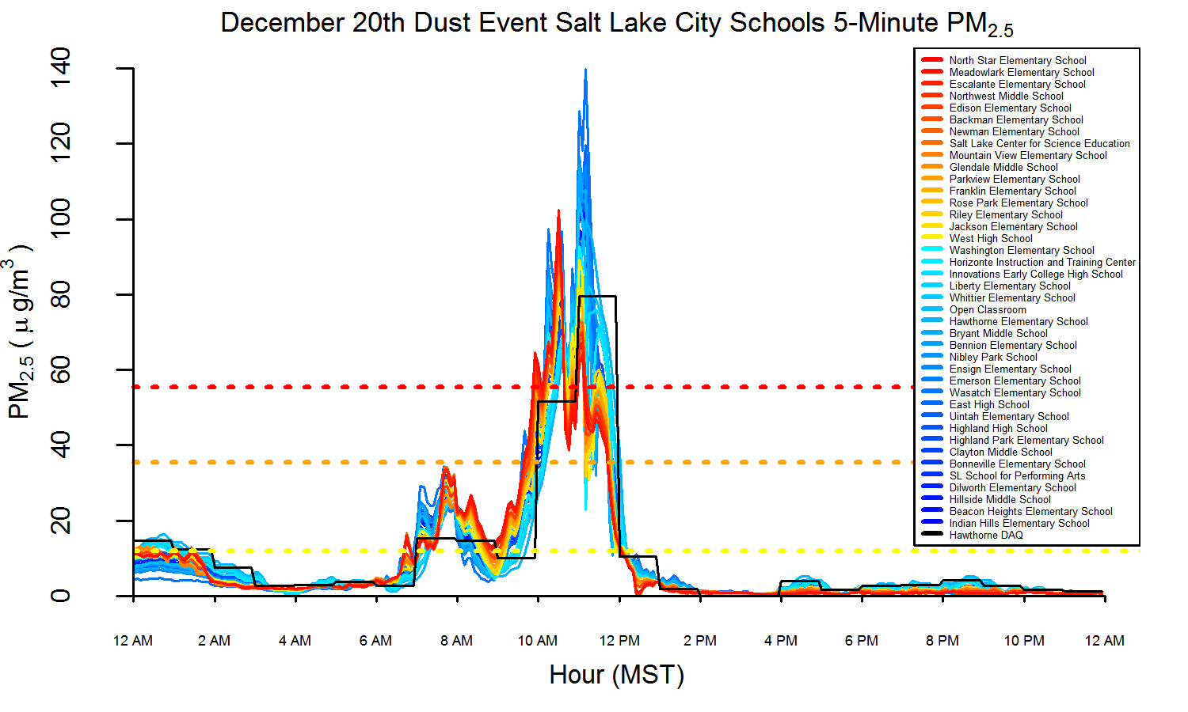

**Figure 2.** Modeled 5-minute PM2.5 at 40 schools in the Salt Lake School District during the dust storm event on December 20th, 2017